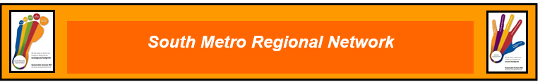

Tuesday 14 May 2024
3.45pm – 5.30pm
Canning River Eco Education Centre
Wilson, Canning
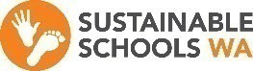
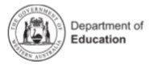
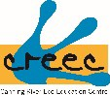

Supporting Education for Sustainability in School Communities

3.45pm Informal Networking - Time for a cuppa…

4.00 pm Acknowledgment of Country

4. 00 pm Two Way Science – new resources for teachers developed by AAEE WA Chapter

Two-way Science provides an opportunity for all students to learn about science from the world’s oldest continuing cultures, to strengthen Aboriginal student wellbeing and engagement and to build respect for Aboriginal histories, cultures, people, knowledges and experiences amongst school staff and students. The Department’s Two-way Science program supports schools to build partnerships with local Aboriginal communities to develop integrated, culturally responsive learning programs that connect Aboriginal knowledge with the Western Australian Curriculum: Science.
4.20 pm Two Way Science Explored

Integrated cross curriculum collaborative curriculum development for your school community. Teachers are encouraged to bring examples of programs, projects or case studies to share. Do you have STEM programs, Arts and Language connections that would support Two Way Science?

5.10 pm

What’s happening in your school? Successes and challenges?

5.30 pm Finish

To register, please follow the link: Events Calendar - Event Details (education.wa.edu.au) for Public School teachers.

Other staff and sustainability champions RSVP info@aaeewa.org.au

Hope you can join us and here is a link to CREEC if you have not been before

https://maps.app.goo.gl/E5AoXWm6bH3ztaDP8

